Chapter 1

Introduction to Operations Management

**Background**

Operations management has created industry giants. The Ritz-Carlton Hotel Company’s mission is to provide an outstanding customer experience through a complete focus on quality management. UPS operates trucks that run for 20 years because their drivers care. Disney has made a science of accurate forecasts and queuing theory. Darden restaurants (Red Lobster, Olive Garden, and others) view operations is their strategy for success. Frito-Lay dominates the snack market by keeping fresh snacks on the shelves with a production process that converts raw materials into a bag of chips sitting in a grocery store in as little as a day or two.

The importance of operations management can be highlighted early in the course with humorous videos or stories about “operations gone wrong.” Most people can share “disaster” stories about poor experiences that they have had dealing with companies.

It can be useful as well to spend some class time right away on the job market for operations management majors, showing starting salaries and job titles compared to other business majors. It can also be helpful to find an MBA program with a strong operations focus and display the starting salaries of those graduates (such data are available on many MBA program websites). Instructors can also share research results showing that (1) more CEOs “learn the ropes” by coming up through operations than any other functional area, and (2) Chief Operating Officer salaries tend to be approximately 10% higher than the salaries of the other “Chiefs” (CFO, CMO, and CIO).

**Class Discussion Ideas**

1. Choose an organization the students will be familiar with and ask them to identify and describe the product of that organization. Direct the discussion to highlight the complex nature of the product offerings of most organizations today where product and service elements are found to some degree in almost all organizations.

2. Have the students choose a few different tasks or jobs and identify possible productivity measures for these. They should describe how they would go about making the necessary measurements. Student and faculty productivity are easy examples that can generate quite a bit of discussion. One possible way to start the discussion is to ask whether grades or research output is an effective measure of student and faculty productivity.

**Active Classroom Learning Exercises**

1. Labor productivity is sometimes perceived to be driven by employee motivation. Have the students split up into small groups to discuss effective ways to motivate hourly employees vs. salaried managers. If productivity of these workers is below expectation, what are good and poor ways to try to motivate them? What methods might work well with blue collar employees but not white collar employees, and vice-versa? What methods might work well in the short run but not in the long run, and vice-versa? Have each student group report its ideas to the whole class. (And if any group has little to say, ask them what could have been done to motivate them to do better!)

2. Companies often locate in other countries to take advantage of low wage rates. However, the difference in labor costs should be adjusted to account for productivity differences among the workers in the two locations. One way to do this is to compute a “relative wage rate” *R* of operating in another country. Note that *R* is not the actual wage rate paid, but it is the hourly wage rate of operating in another country *relative* to the home country, after taking productivity differences into account. If the foreign country’s workers are more productive, *R* will decrease, and vice-versa. The formula is *R* = (*W* ÷ *X*)(*U* ÷ *F*), where *W* = the foreign wage rate (in foreign currency per hour), *X* = the exchange rate (in foreign currency per local currency), *U* = home country productivity (in units per hour), and *F* = foreign country productivity (in units per hour).

A problem could be described as follows. Suppose that workers in Britain earn ₤10/hour. The exchange rate with the U.S. is $1.5 per ₤1. American workers can produce 40 units per hour, while British workers at a similar facility can produce 50 units per hour. If the U.S. wage rate is $14 per hour, should the firm produce in the U.S. or in Britain?

Have the students try the exercise in class. They will probably analyze this problem by computing a labor cost per unit in each country (35 cents vs. 30 cents). Then introduce the concept and formula for relative wage rate (*R* = $12 in Britain). Both approaches are equally accurate, but using a relative wage rate has political advantages, i.e., it seems easier to talk about one wage rate vs. another ($14 vs. $12) as opposed to comparing costs per unit (35 cents vs. 30 cents).

**Company Videos**

1. *Frito-Lay: Operations Management in Manufacturing (7:11)*

Frito-Lay, a subsidiary of PepsiCo, has over 40 product lines, seven of which having sales exceeding $1 billion *each*. In this video, the textbook authors review the 10 OM strategy decisions and briefly describe how Frito-Lay addresses each one. For example, the company is constantly innovating with new products. For quality assurance, it uses multiple inspection points both within and outside the factory, and it utilizes statistical process control. The plant applies a product focus strategy, which is appropriate for a high-volume, low-variety producer. As raw materials are perishable and shelf life is relatively short, plant location decisions are driven by proximity to raw materials or markets. The plant has low employee turnover, driven by good benefits, respect for people, and a strong concern for safety and ergonomics. Inventory levels are quite low, and inventory is turned over 200 times per year. Potatoes are delivered 10 times per day. Schedules are driven by demand forecasts and adjusted for local events, such as the annual Daytona 500 auto race. All of these practices, along with excellent layout, supply-chain, and maintenance policies, have helped to make Frito-Lay the world’s largest snack manufacturer.

If the video is shown before the 10 OM decision are covered, prior to showing the video the instructor could ask the students to list the major decisions that they think that operations managers make. Afterwards, the 10 decisions from the book can be compared to the student lists. Then the instructor can choose a different company, perhaps a service organization, with which students might be familiar. The class could try to identify ways in which that organization addresses the 10 decisions and perhaps compare those to some of Frito-Lay’s tactics.

2. Hard Rock Cafe: Operations Management in Services (8:26)

Hard Rock is interesting because it’s so much more than just a restaurant. Management speaks about its “experience strategy,” which, in addition to quality food, includes rock-and-roll memorabilia, music, lighting, jovial staff, and a retail store. The video is sprinkled with scenes of happy employees dancing around or volunteering in the community. Most of the video is spent covering how Hard Rock Cafe approaches some of the 10 operations management decisions. For example, (1) scheduling is driven by forecasts that are based on prior sales, seasonality, recent trends, and current local events; (2) cafe layout focuses on maximizing the customer experience and driving customers toward revenue-generating activities; and (3) inventory management goes well beyond the inventory of food and retail items—Hard Rock has a $40 million inventory of rock-and-roll memorabilia to manage, and each restaurant goes through a complete changeover of memorabilia every 5-7 years.

As an entertaining piece and one that covers a variety of OM decisions, this is certainly a good video to show early in the course when discussing Chapter 1. Many students will have eaten at a Hard Rock Cafe themselves, and most should enjoy seeing memorabilia from rock stars such as Madonna and KISS. This is also a good way early in the course to show that operations management is just as important in services as it is in manufacturing. Prior to showing the video, the instructor might ask the students to think about the 10 OM decisions and how Hard Rock approaches them. Afterwards, discussion might revolve around aspects of those decisions that are unique to service businesses in general and then to Hard Rock Cafe in particular. Two clear differences about Hard Rock Cafe itself are (1) because of and contributing to such successful branding, the cafe’s retail sales (shirts, etc.) account for nearly the same amount of revenue as the main product (the food) itself; and (2) the management of the memorabilia around the world represents a unique and extremely important management effort on its own.

**Cinematic Ticklers**

1. *Fawlty Towers*: *“Waldorf Salad*” *(John Cleese and Prunella Scales), CBS/FOX VIDEO, 1986 (1979)*

This can actually be the first thing done in class all semester. The very start of the episode contains a funny scene about suppertime in the dining room of a bed and breakfast in England. The owners and staff make numerous errors. A class discussion can directly follow, listing what went well (almost nothing) and what didn’t (many things). This clip can start a course off well because: (1) it’s a very easy way to create an atmosphere of student participation right away in the course—identifying poor operations is easy in this clip, (2) it emphasizes right away that operations management applies to services, not just manufacturing, and (3) it’s a fun way to begin a course.

2. *The Simpsons, Season 7: “King-Size Homer,”20th Century Fox Video, 2006 (1995-1996)*

Homer gets so fat that he is allowed to work from home. He realizes that he can triple his productivity by just pressing “Y” on his computer instead of typing “YES”.

3. *The Simpsons*, *Season 8: “You Only Move Twice,” 20th Century Fox Video, 2006 (1996-1997)*

Homer gets a new job working for a James Bond-like villain. He is put in charge of a set of three workers. It’s his job to motivate them. As they type along, Homer asks if they are working. “Yes,” they reply. “Can you work any faster than that?”, he asks. “Sure thing, Mr. Simpson,” they say, as they start typing faster. (If only motivation were that easy.)

4. *Modern Times*, *(Charlie Chaplin), CBS/FOX VIDEO, 1992 (1936)*

The movie deals with worker alienation in an assembly line environment and offers an interesting historical perspective on early Taylorism. Interesting issues arise, including workers having to clock out to go to the bathroom, the automatic assembly line being sped up as the day wears on, sneezing or scratching being enough to make one behind on his or her work, and, most importantly, the de-humanization of early assembly line work.

**Presentation Slides**

INTRODUCTION (1-1 through 1-7)

Slide 7: This Global Company Profile from the first chapter helps to illustrate the wide variety of decisions that an operations manager must face. In the case of Hard Rock Cafe, the “product,” includes more than tasty meals—the layout, the memorabilia on display, and the service all encompass the dining package from Hard Rock that consumers now expect. The meals themselves are designed, tested, and then analyzed for the cost of ingredients, labor requirements, and customer satisfaction. Among other tasks, the operations manager must consider both the attractiveness and efficiency of restaurant layout, supplier quality and reliability, employee motivation and training, maintenance of tight schedules, and preparation of outstanding meals.



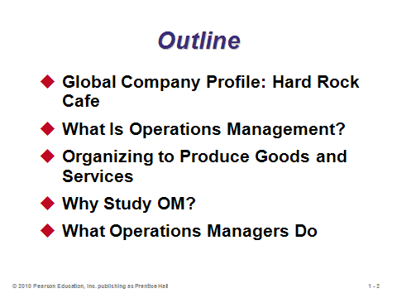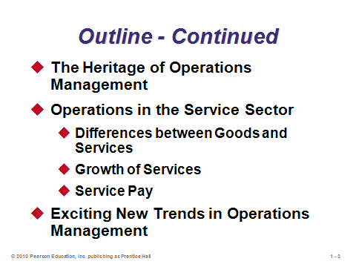

**1-1 1-2 1-3**

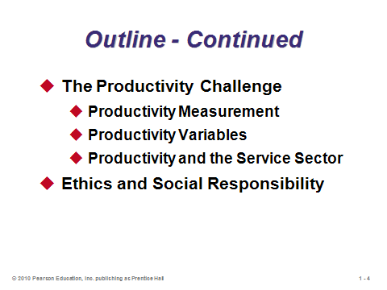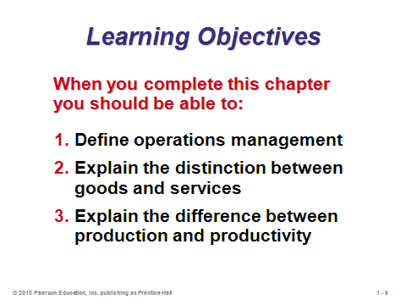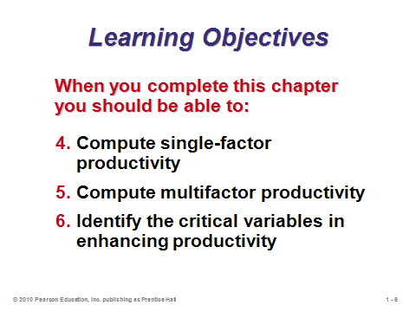

**1-4 1-5 1-6**

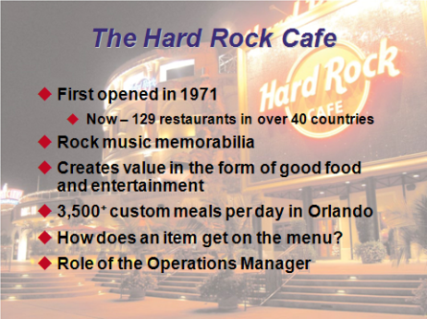

**1-7**

WHAT IS OPERATIONS MANAGEMENT? (1-8)

Slide 8: Starting with the Hard Rock Cafe example, it is important to stress from the very beginning of the course that operations management applies just as much to service businesses as to manufacturing businesses.

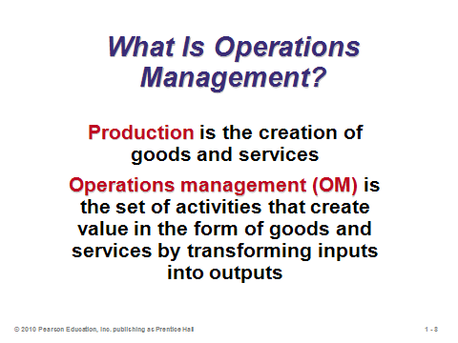

**1-8**

ORGANIZING TO PRODUCE GOODS AND SERVICES (1-9 through 1-12)

Slide 9: To create goods and services, all organizations must perform the three functions identified on this slide. Firms must create demand, satisfy that demand, and manage and monitor the financial flows associated with creating and satisfying that demand.

Slides 10-12: These slides (Figure 1.1) present example organization charts from three different companies. The areas in blue indicate the significant role that operations management plays in both manufacturing and service firms.

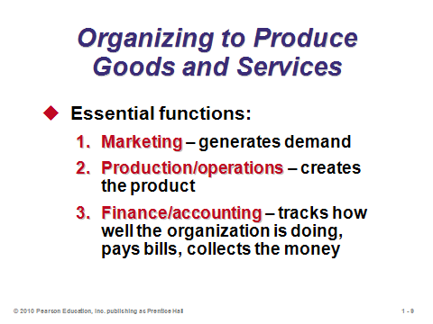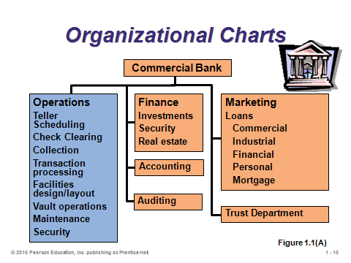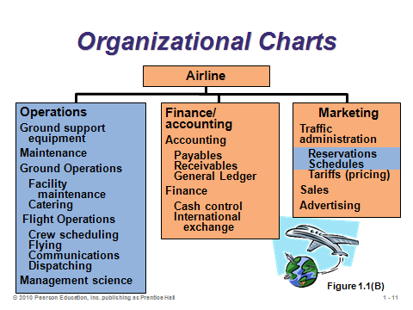

**1-9 1-10 1-11**

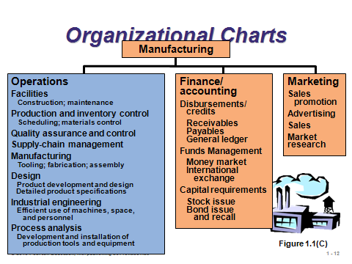

**1-12**

WHY STUDY OM? (1-13 through 1-14)

Slides 13-14: These slides can be used early on in the course to help “sell” the usefulness and importance of the class. In most cases, a large percentage of revenue is spent on the OM function. Slide 14 (Example 1) shows a common circumstance, that is, often the best and easiest way to meet improved contribution targets is through finding efficiencies in operations. In this particular example, the hefty requirements for the marketing and finance options might make them infeasible anyway.

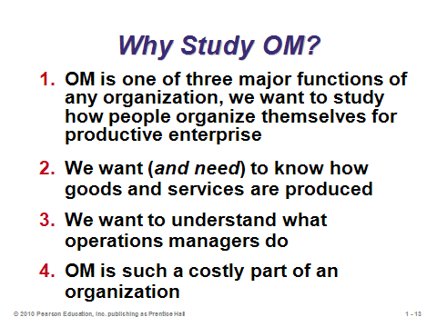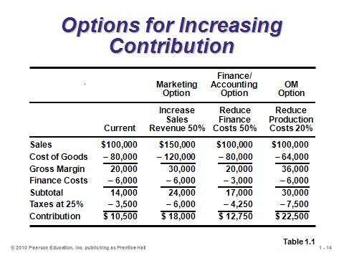

**1-13 1-14**

WHAT OPERATIONS MANAGERS DO (1-15 through 1-24)

Slide 15: All good managers, including operations managers, perform the basic management functions identified in this slide.

Slides 16-21: The 10 critical OM decisions are useful to cover one-by-one, not only as a precursor to the rest of the text, but also to emphasize the wide array of responsibilities that are under an operation manager’s jurisdiction. Slide 16 maps them to the rest of the text, while Slides 17-21 provide examples for each decision of questions that the operations manager must address.

Slides 22-24: Salary information pertaining to local students (perhaps with help from the university’s career center) can be combined with Slides 22 through 24 to help sell the operations management field as a viable career option for students. A very common entry-level position for OM majors is in the *purchasing* area of organizations. Slide 23 (Figure 1.2) identifies several of the many types of career opportunities that exist for operations managers. The organizations identified in Slide 24 provide various certifications that may help forward students’ careers. The Six Sigma Green Belt and Black Belt certifications offered through the American Society for Quality represent relatively new and highly sought after acknowledgements of professional expertise.

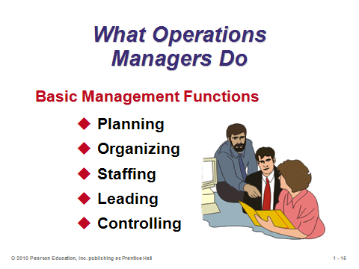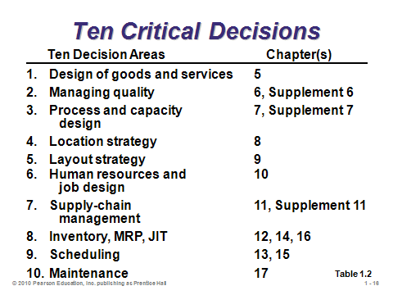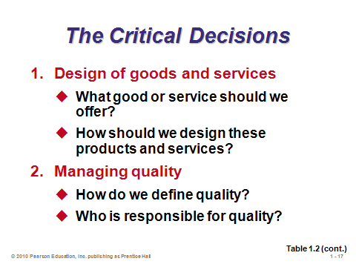

**1-15 1-16 1-17**

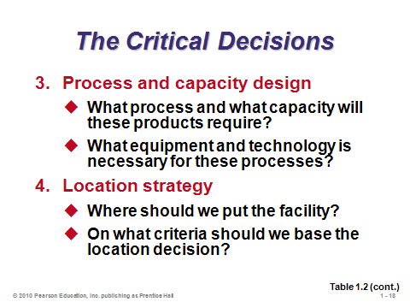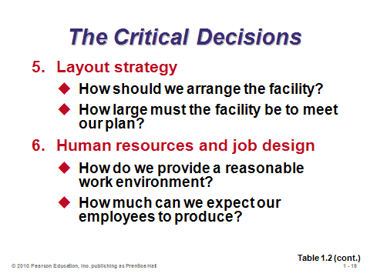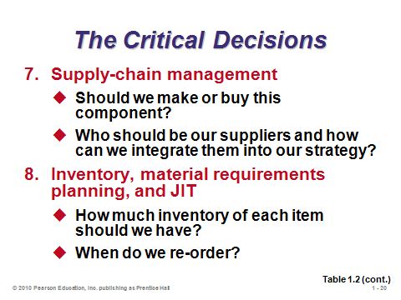

**1-18 1-19 1-20**

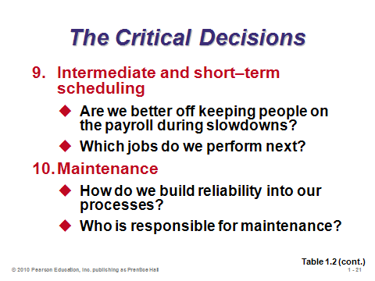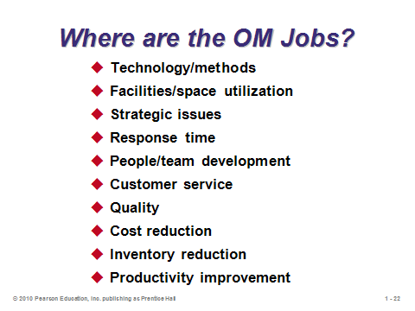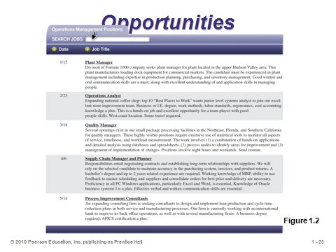

**1-21 1-22 1-23**

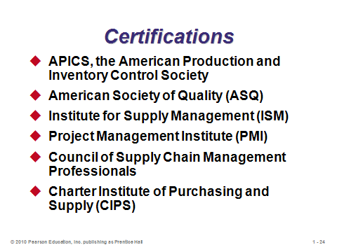

**1-24**

THE HERITAGE OF OPERATIONS MANAGEMENT (1-25 through 1-35)

Slide 25: This slide (Figure 1.3) presents a nice summary of the past and future of OM. Videos showing historical footage (see Other Supplementary Material below), can fit in well here.

Slides 26-33: Presenting students with a good historical context of the field is important. There is a lot of important history there that is directly tied to the economic growth of nations. Slides 26 and 27 supplement Slide 25 and provide more specific timing. Slides 28-33 provide information about some of the most important historical figures in the field.

Slide 34: Operations management continues to progress with innovations and contributions from other disciplines, particularly those identified on this slide.

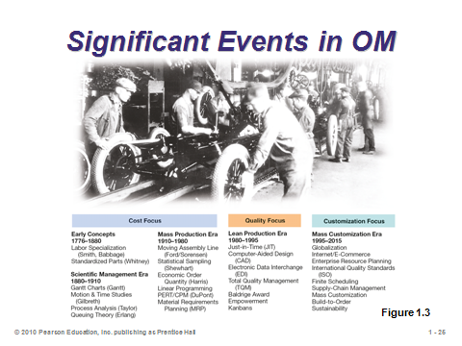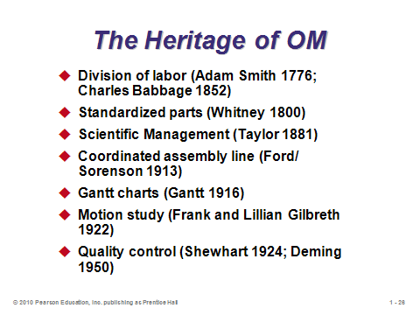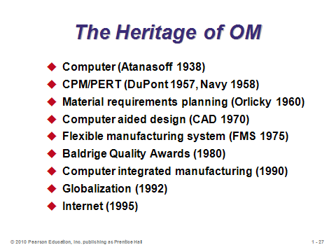

**1-25 1-26 1-27**

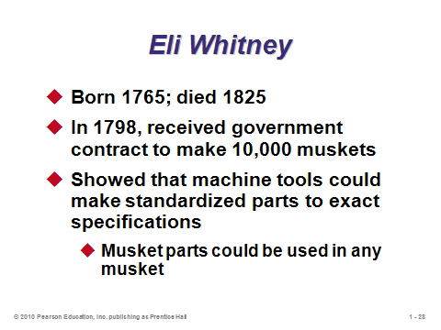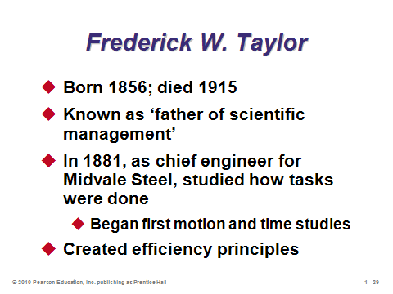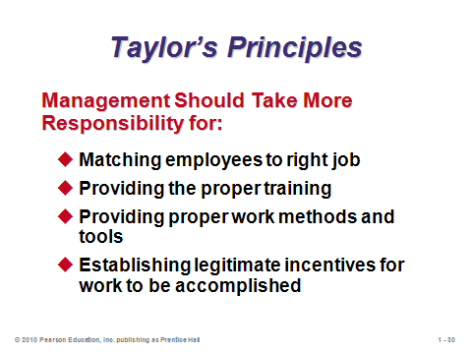

**1-28 1-29 1-30**

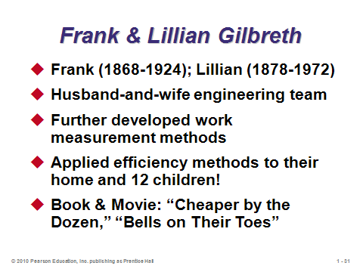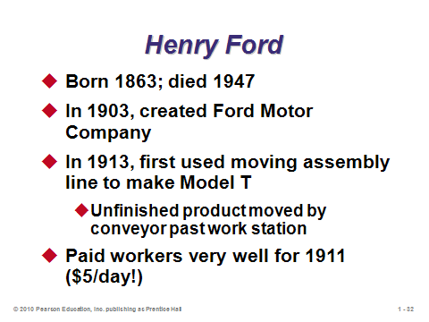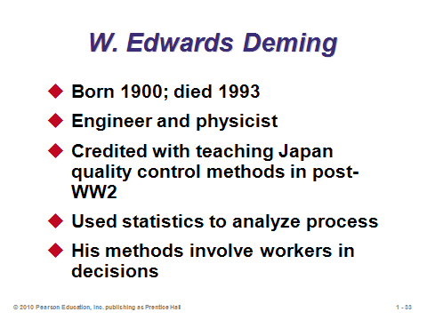

**1-31 1-32 1-33**

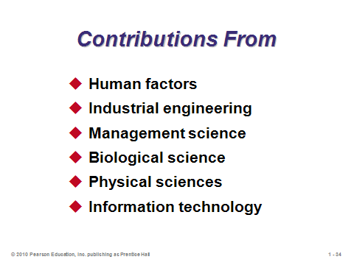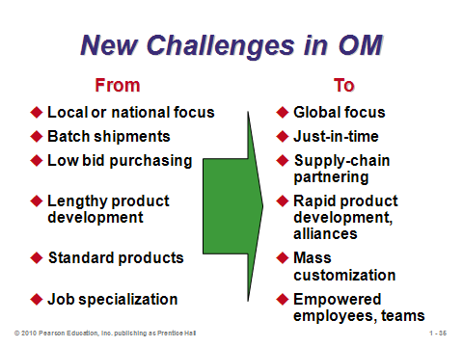

**1-34 1-35**

OPERATIONS IN THE SERVICE SECTOR (1-36 through 1-45)

Slide 36-37: The manufacturing-service distinction is more like a continuum (see Slide 39), as most manufacturing companies provide some services (e.g., financing from an auto manufacturer) and most service companies provide some goods (e.g., shampoo at a hair salon). Nevertheless, the two extremes differ in important ways, which may impact how operations managers approach decision making in one case vs. another. These two slides identify the major differences.

Slide 38: This slide shows that in most industrialized countries, services represent a much larger percentage of GDP than manufacturing does.

Slide 39: The continuum of goods and services is illustrated in this slide, showing that the distinction is not always so clear-cut.

Slides 40-42: These slides (Figure 1.4) illustrate the tremendous growth of services over the last several decades. Slide 41 shows that industrial output has risen sharply, despite a flat employment base—this is due to tremendous productivity growth in manufacturing. The huge productivity increases in agriculture and manufacturing have allowed more of our economic resources to be devoted to services. Consequently, much of the world can now enjoy the pleasures of education, health services, entertainment, etc.

Slides 43-45: These slides (Table 1.3) provide examples of firms and percentages of employment in the U.S. in various sectors of the economy. More than half of the students taking this class will likely end up working for a firm in the service sector.

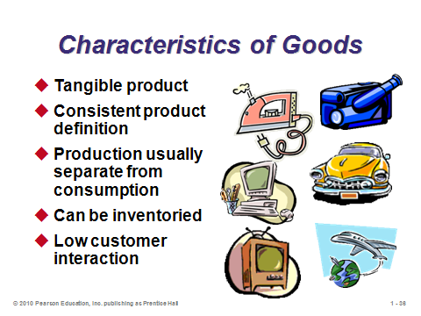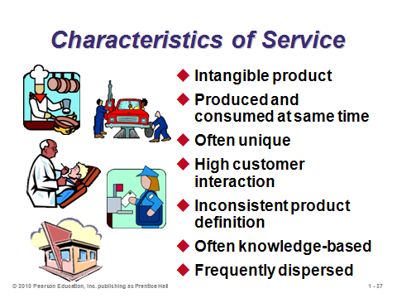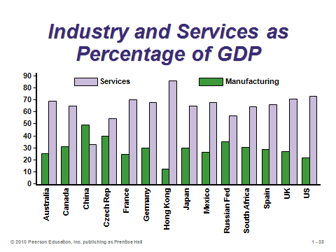

**1-36 1-37 1-38**

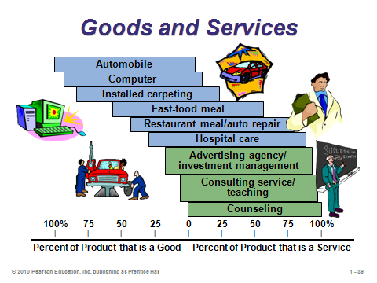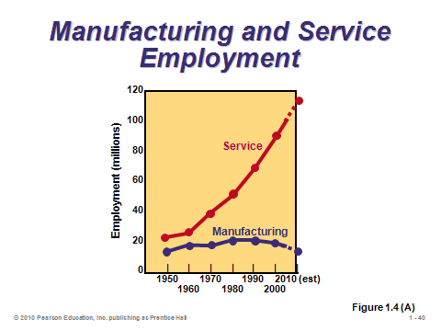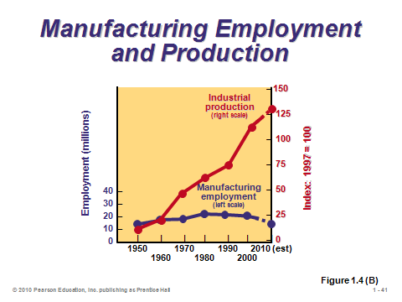

**1-39 1-40 1-41**

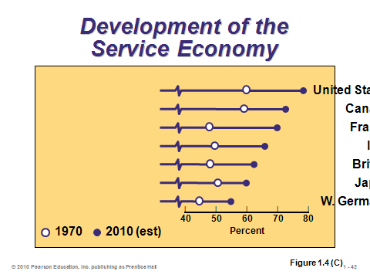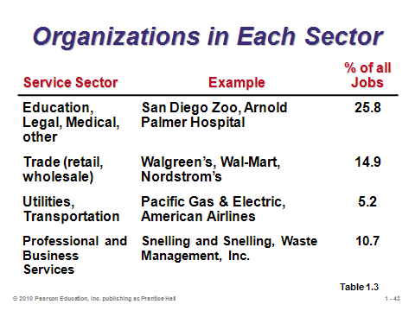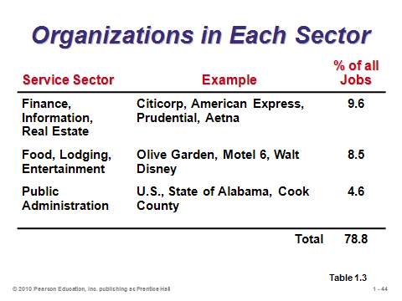

**1-42 1-43 1-44**

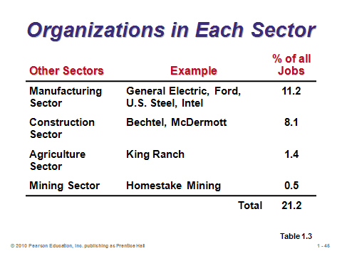

**1-45**

EXCITING NEW TRENDS IN OPERATIONS MANAGEMENT (1-46 through 1-49)

Slides 46-49: Slides 46-48 (Figure 1.5) provide a nice summary of how some traditional operations areas of emphasis are changing, and, importantly, why those changes are taking place. The full set is identified on Slide 49.

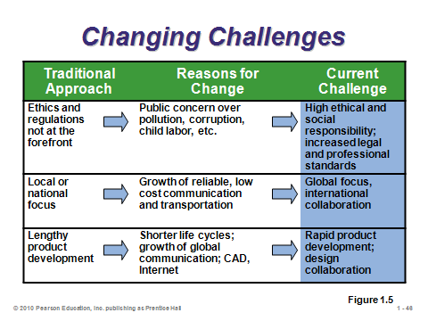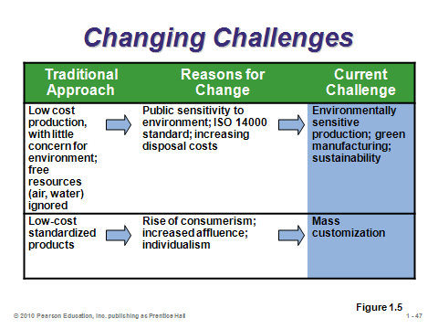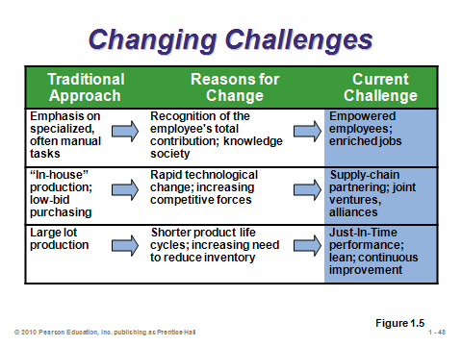

**1-46 1-47 1-48**

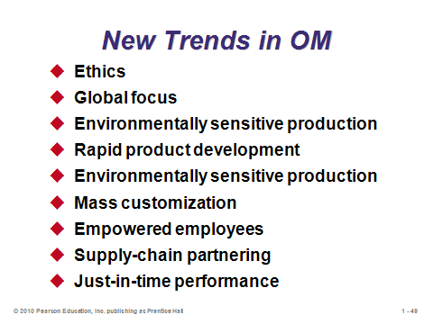

**1-49**

THE PRODUCTIVITY CHALLENGE (1-50 through 1-72)

Slide 50: The basic formula for productivity is simple: *outputs* ÷ *inputs*. This sometimes varies as interest focuses on a specific output or input or a set of outputs or inputs. At the firm level, productivity improvement usually leads to greater profits. At a macro level, productivity improvement in an economy usually leads to a higher standard of living. Productivity improvement means getting more “bang for the buck:” either (1) reducing inputs while keeping output constant, or (2) increasing output while keeping inputs constant.

Slide 51: This slide (Figure 1.6) describes how productivity in the U.S. economy grows at about 2.5% per year, comprised of capital factors (0.95%), labor factors (0.25%), and management factors (1.3%). The picture also suggests that an effective feedback loop is an important component for continuous improvement.

Slides 52-53: These slides (OM in Action) describe how some relatively simple management and equipment changes improved Starbuck’s productivity significantly, which led to six-figure increases in revenue *per outlet* over a six-year time period.

Slides 54-56: The most common productivity formulas are presented in these slides. Slide 54 shows the basic formula. Slide 55 provides an example of a *single-factor* productivity measure, in this case the common measure of labor productivity. Slide 56 is a *multifactor* productivity measure. Note that a multifactor measure only makes sense if all of the inputs are expressed in the same units (usually a monetary unit such as dollars).

Slides 57-64: These slides illustrate Example 2 from the text, calculating both single-factor and multifactor productivity measures. Here, as in most cases, the multifactor measure makes more sense because it includes all costs connected with the increase in output. In fact, a situation that replaces workers with more expensive robots may appear to improve labor productivity but may actually be deceasing multifactor productivity (and firm profits) overall.

Slide 65: These potential measurements problems with productivity should be emphasized. If evaluating performance of a plant, a manager, a division, etc., it is important to compare “apples to apples” and to evaluate individuals on outcomes over which they have control.

Slide 66: The three factors identified in this slide are critical to achieving improved productivity. The percentages listed represent their respective historical contributions to productivity improvement.

Slide 67: As we see in this slide, sometimes training and education produce more productive workers, while in other cases, the workers’ general health along with environmental factors may determine their respective capabilities.

Slide 68: As unbelievable as it seems, a large number of U.S. high school students cannot solve very simple math problems, such as those shown in this slide (Figure 1.7). It has been suggested that perhaps up to 25% of U.S. workers lack the basic skills needed for their current job. The situation may be even worse in some other countries, particularly in some of the low-wage countries.

Slide 69: Historically, annual capital investment in the U.S. has increased at an annual rate of 1.5% after allowances for depreciation. In general, higher investment levels lead to higher productivity gains.

Slide 70: The items identified in this slide all contribute to the difficulty in improving productivity in the service sector.

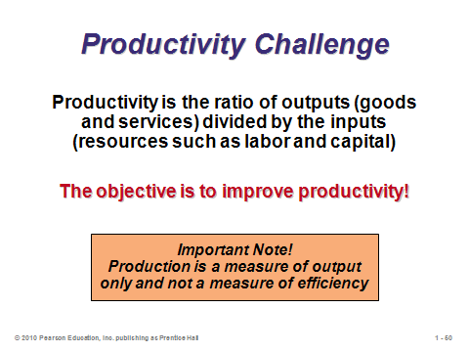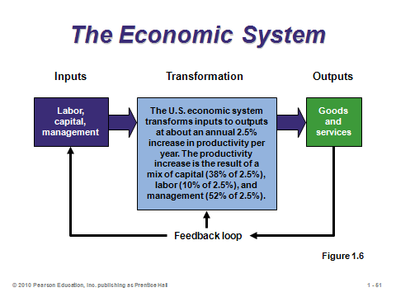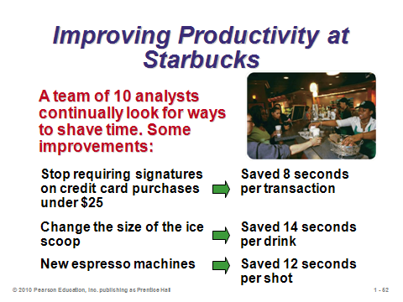

**1-50 1-51 1-52**

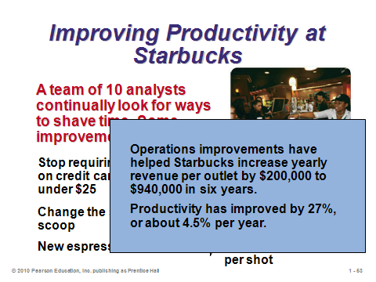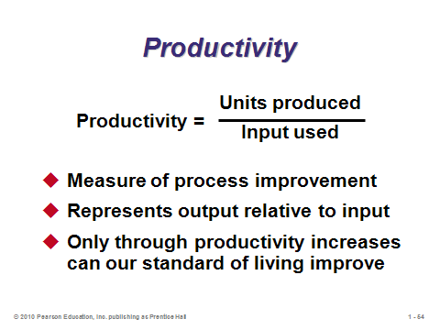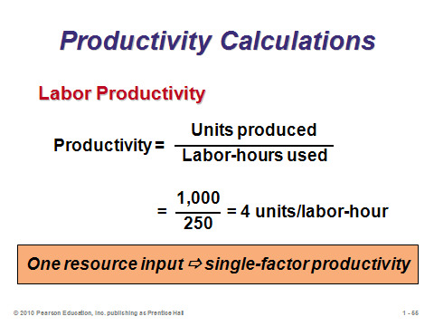

**1-53 1-54 1-55**

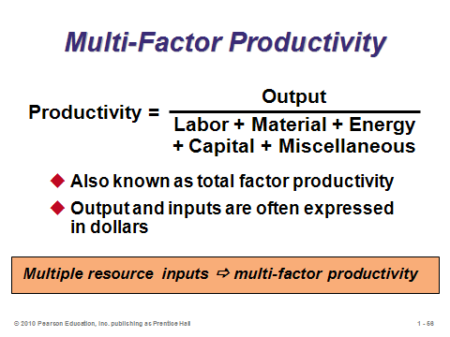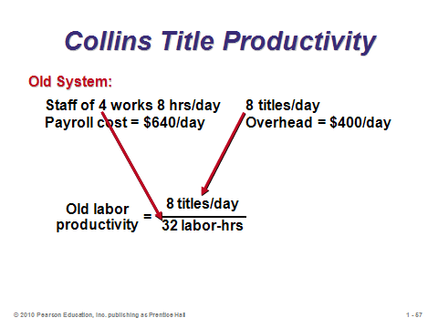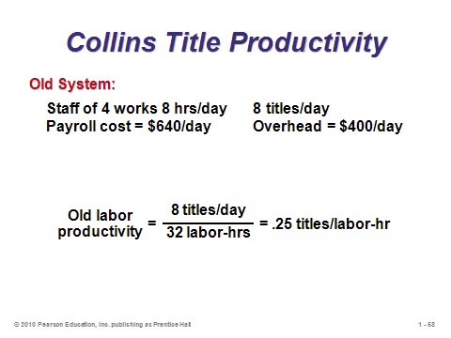

**1-56 1-57 1-58**

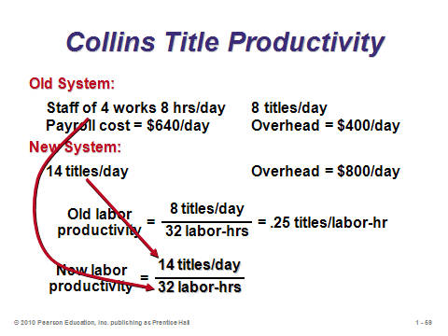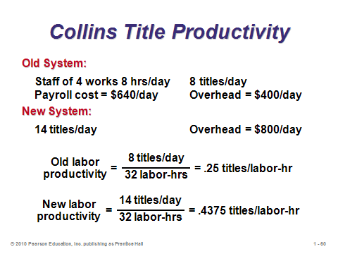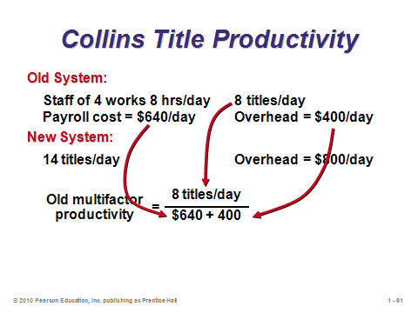

**1-59 1-60 1-61**

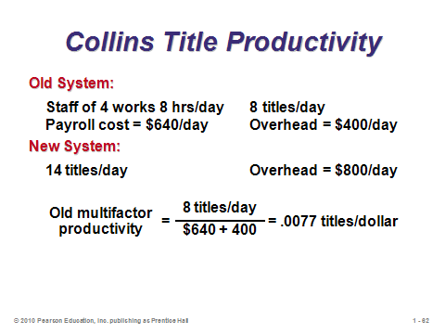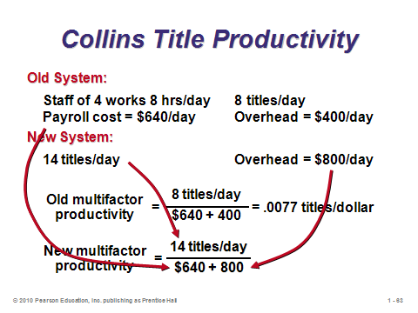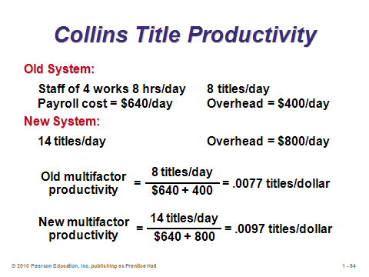

**1-62 1-63 1-64**

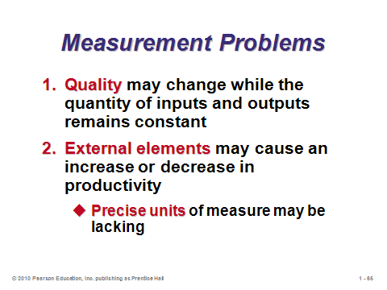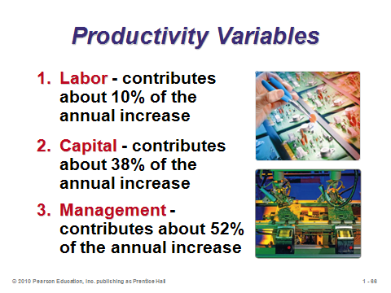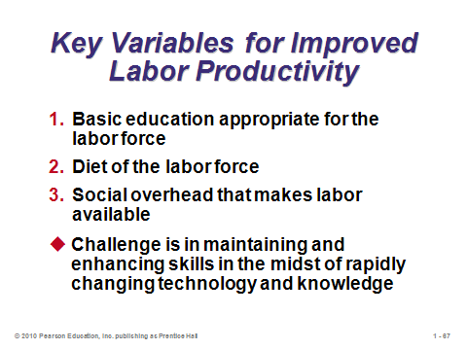

**1-65 1-66 1-67**

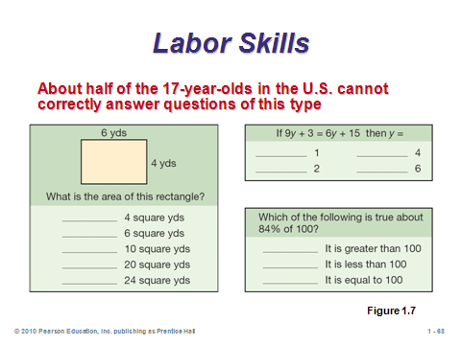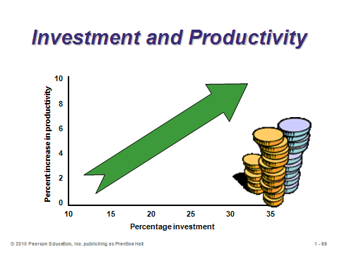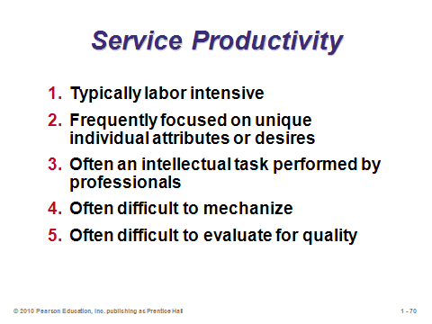

**1-68 1-69 1-70**

ETHICS AND SOCIAL RESPONSIBILITY (1-73)

Slide 71: Managers must address the challenges identified in the slide, along with many other challenges, in an ethical and socially responsible way while meeting demands of the marketplace.

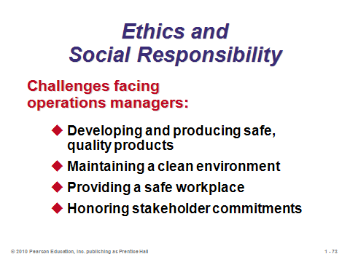

**1-71**

**Additional Assignment Ideas**

1. Search the Internet for organizations that offer productivity consulting services; there will be quite a few. Different organizations will offer different service packages and specialize in different areas. Pick two organizations that demonstrate differences and compare and contrast their services, their areas of specialization, and their approach to productivity. That is, explain how they are similar and how they are different. Make sure you include examples from their Web sites that support your analysis. (Two examples are Proudfoot Consulting (http://www.proudfootconsulting.com/) and LxLi (http://www.lxli.com).)

2. Labor productivity is by far the most commonly seen expression of productivity. Search the Internet for sites that offer labor productivity statistics. Certainly, the Bureau of Labor Statistics (www.bls.gov) is one, but there are others from around the world. Compare the labor productivity in the U.S. for the past decade to that of another country of your choosing. How and why are they different or similar?

3. Students can be assigned a paper that compares the service company Hard Rock Cafe to the manufacturing firm Frito-Lay, both of which have videos for Chapter 1. Specifically, the paper could compare and contrast how the two firms approach the 10 major OM decisions described in the text.

**Additional Case Studies**

Internet Case Study (www.pearsonglobaleditions.com/heizer)

* *Zychol Chemicals Corp.*: The production manager must prepare a productivity report, which includes multi-factor analysis.

Harvard Case Study (http://harvardbusinessonline.hbsp.harvard.edu)

* *Taco Bell Corp.* (#692-058): Illustrates the power of breakthrough thinking in a service industry.
* *Singapore Inc.* (#703-040)**:** This case examines several key aspects of Singapore's growth, including organizational/cultural arrangements, the savings/investment balance, and total factor productivity growth.

Richard Ivey School of Business (http://cases.ivey.uwo.ca/cases/pages/home.aspx)

* *New Competitive Game in Asia* (#9B01TA05): There is a drive for productivity improvements across a broad front, not just in the manufacturing sector. Firms that once competed on price alone are busy differentiating themselves in other ways; companies that once engaged in asset arbitrage have recognized the error of their way and are focusing on their operating strengths; and companies are shifting from horizontal to geographic diversification.
* *Jinjian Garmet Factory: Motivating Go-slow Workers* (#9B04T033): Jinjian Garment Factory is a large clothing manufacturer based in Shenzhen with distribution to Hong Kong and overseas. Managers in this industry still had few effective ways of dealing with the collective and deliberate slow pace of work by the employees, of motivating workers, and of resolving the problem between seasonal production requirements and retention of skilled workers.

**Internet Resources**

|  |  |
| --- | --- |
| American Productivity and Quality Center | www.apqc.org/ |
| American Statistical Association (ASA) offers business and economics DataLinks, a searchable index of statistical data | www.econ-datalinks.org/ |
| Economics and Statistics Administration | www.esa.doc.gov |
| Federal Statistics | www.fedstats.gov |
| National Bureau of Economic Research | www.nber.org |
| U.S. Bureau of Labor Statistics | stats.bls.gov |
| U.S. Census Bureau | www.census.gov |

**Other Supplementary Material**

Videos

1. *Modern Marvels*, “The Assembly Line.”

The first part of this History Channel production shows Henry Ford and the Ford assembly line, with real historical footage. It describes the poor working conditions, as well as Ford’s response, which was to pay a very high hourly rate for the time.

2. *Loose Bolts*, Michael Keaton. Offers a more modern perspective on assembly lines and highlights the difficulties of making changes in existing organizations when implementing productivity improvement programs.

3. *Ford Historic Model T*, CarDataVideo (5:16), http://www.youtube.com/watch?v=S4KrIMZpwCY

This narrated video has a very detailed look at the first assembly lines at the original Ford auto plant, plus some driving scenes with the Model T.